AVR VIEWZ

**Menu bar**

About viewz

Pricing

Blogs

Contact us

**Homepage:**

**Block 1**

Headline:

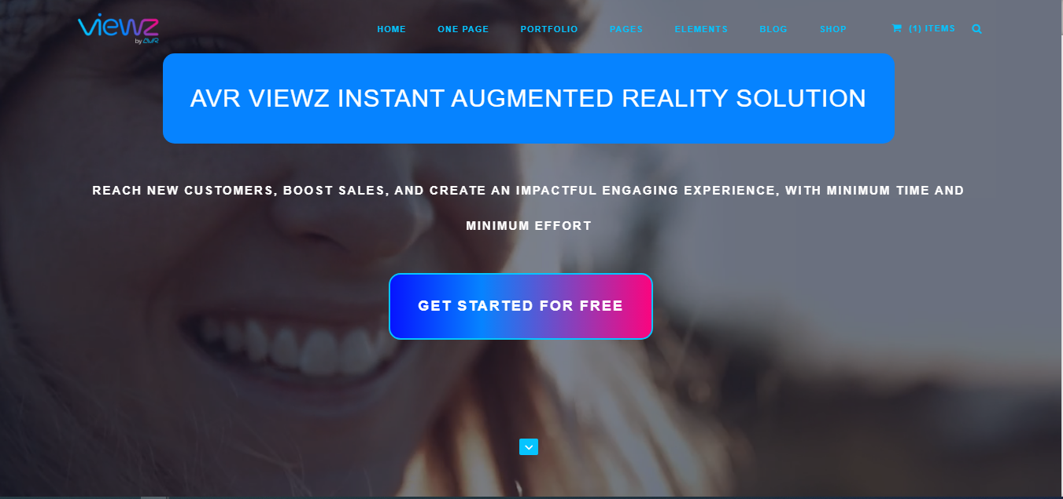

AR for everyone with Viewz the e-commerce soulmate

This sentence should be in the blue box, but please remove the box just add the text without any background



And make the colors gradient please



Decrease the size of this button and drag it down a bit

Keep the rest as it is

__________________________________

**Block 2:**

Supporting headline: (in the middle)

We should change the background

Simple inclusive and powerful Web AR

Augmented reality never been so easy!

I have edited the text please change it

With Viewz, you can transform your 2D images into augmented reality in a snap, just drag, and drop, examine, and publish your augmented products on your website. Get a branded QR code, shareable dedicated link, and analytics for your products, and many more benefits of our web AR.

CTA: get started for free

__________________________________

**Block3:**

Viewz the e-commerce soulmate

Display your flooring, decorative products, and furniture with the ultimate try-before-you-buy experience, and reach countless users with our innovative web AR.



Here remove this block



Merge these in one block:



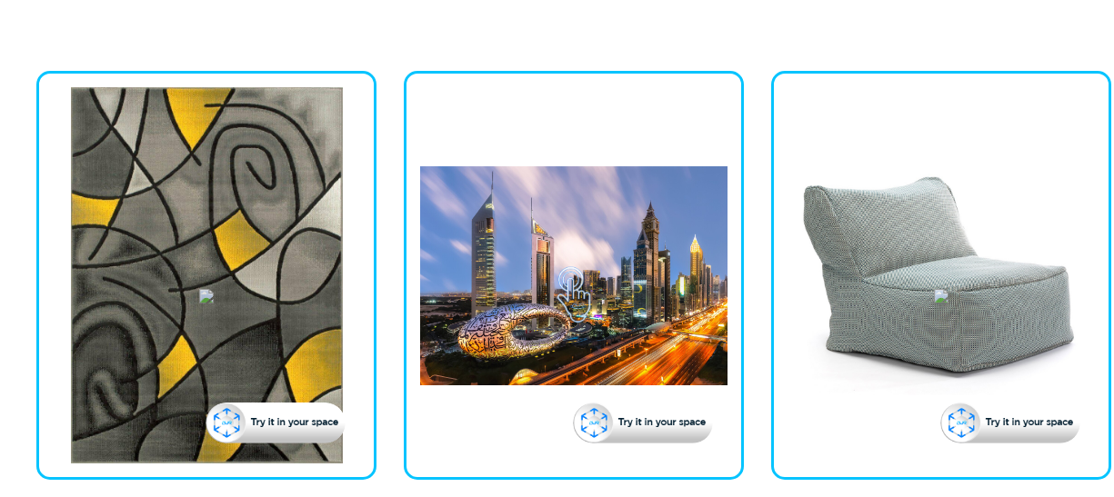

Bring your customers a long-lasting impactful experience and let them have real-time interactions with your products in their own environment at any time.

__________________________________

**Block 4:**

**Industries**

“All images here should be small videos about the service”

“To the left a video of AR art”

To the right text:



Go viral with AVR Viewz

AR your ART with Viewz

Viewz can convert any 2D image of your artwork into an AR experience including a number of frame templates that can be used from our library.

Read more button takes the user to:

### Art & Design



Here the opposite and this text to the left

“Video about AR for the entire floor”

Make sure your customer will not leave without making a purchase

Your customers will have the ability to ‘try-before-buy’ AR experience, not only for carpets, and rugs but also for tiles, parquet, and all flooring products! Viewz can convert a single tile image into an entire floor.

With Viewz you can give your clients the real-time experience of the entire floor.

Read more button takes to

### Flooring products

Then this



“Video about AR for the entire wallpaper or painting”

**The ultimate try before buy experience for your customers**

With Viewz you have a unique feature that enables you to convert a single piece of wallpaper pattern image into a full wallpaper AR experience, which will help your clients see exactly how it would look like in reality.

Read more button takes to

### Wall Coverings

And can you please add one section to them; the video to the right and the text to the left:

**Transform your e-commerce platform into a selling machine**

Furniture is not a product that is easy to move, try or return, by offering your prospects the ability to view and try your furniture in their place, you are creating a strong emotional connection with your prospects, which will convert them into customers, boost sales and reduce returns.

Read more button takes to

### Furniture industry

__________________________________

**Block 5:**

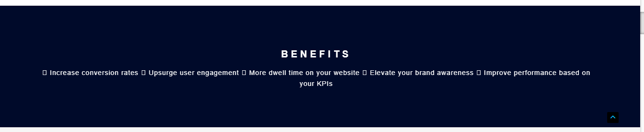

Benefits:

By using AVR Views you will:

* Increase conversion rates
* Upsurge user engagement
* More dwell time on your website
* Elevate your brand awareness
* Improve performance based on your KPIs

__________________________________

**Block 6:**

### Convenient

You can launch it from social media, email marketing or directly from your website.

### Analytics/ Web data

Analytics to Track the performance of your projects and consumer behavior with the built-in analytics system

### Personalized branding

Branded QR code, custom URL with your name / company name, and an I-Frame that you can embed to your online gallery website or e-commerce store.

### Easy for user and customer

User- friendly dashboard, easy to follow steps, just drag, drop, test, and publish. Also, Viewz has extremely low barriers to use for customers, can be accessed via native smartphone camera and mobile web browser.

### Ultimate Compatibility

Viewz is compatible with both iOS and Android operating systems.

### Wall and floor product visualizer

Viewz allows your customers to select their favorite floor product and try it on their entire floor before buying it.

### Storage/ hosting

__________________________________

**Block 7:**

Our plans

“Pricing”

__________________________________

**Block 8:**

Frequent Q&A

**1-What is Viewz studio?**

It is a Web AR, a no app augmented reality content creating solution enables you to augment your products instantly without the need for app downloading or coding knowledge. They can be integrated to any web browser. Users can access web AR by clicking a link or scanning a QR code to open the items on your website.

**2-Do I need any coding skills to use Viewz?**

Not at all, all you have to do is to drag and drop your 2D images, test, adjust, publish, and you are done.

**3-Can I publish AR experience for free?**

Yes, you can get a basic plan for this. This license is limited to prototypes and demonstrations (it cannot be used for commercial purposes) for 15 days only. To publish an experience for commercial use, you need to subscribe to one of our packages.

**4-How do I subscribe?**

Just signup with your email to subscribe.

**5- Can I upgrade my subscription, and how?**

Yes, you can to go to the subscription page and from there you can upgrade your subscription

**5- Can I cancel my subscription at any time?**

Yes

**6- Can I get a refund?**

No, refund is not possible

**7- Where are the assets stored?**

AWS servers in multiple locations

__________________________________

**Block 9:**

About Viewz:

Viewz is an AR platform that converts the images of art, floors, walls, furniture, and products into Augmented Reality in a seamless easy way to provide you with the ultimate try-before-buy experience for your consumers.

CTA: subscribe to our newsletter

Contact us:

**About Viewz page**

**Block 1:**

***AR your products in a snap with Viewz***

***“A seamless, reliable, and efficient web AR studio for an immersive, interactive, and attractive shopping experience”***

**CTA button: Get started for free**

**Block 2:**

### About Viewz

Based on our belief in the essential role of technology in the economic modern world, we decided to build the seamless, reliable, and efficient augmented reality platform for retailers, to help them promote and display their products in an immersive, interactive, and attractive way.

Viewz is an AR platform that converts the images of art, floors, walls, furniture, and products into Augmented Reality in a seamless easy way to provide you with the ultimate try-before-buy experience for your consumers.

With the aim to make AR technology available and accessible for every retailer, we have built Viewz as an excellent option for Art, flooring, wall hangings, and furniture retailers looking to engage consumers across digital and physical channels, Viewz is a modern platform that will help you provide the ultimate easy and smooth AR online shopping experience for your customers.

**Block 3:**

### Why Viewz?

Viewz is a one-time effort, all-time gains; by using Viewz you will bring your customers a long-lasting impactful experience and let them have real-time interactions with your products in their own environment at any time, also Viewz is:

### An innovative solution

Viewz allows retailers, especially merchants of hard-to-try or return products such as flooring products and furniture, to promote their products allowing customers to try the products in an interactive way, which will increase sales and reduce returns.

### Sustainable solution

Viewz is an eco-friendly solution that helps reduce emissions by reducing the amount of returned and exchanged merchandise through a try-before-buy AR experience, which meets most consumer demands for sustainable practices.

### Simple Effortless solution

Simple, easy, fast, and within reach platform, no need for app downloading or coding experience, all you need to do is drag, drop, test, and publish; and all your customers need to do is click, try, and then buy!

### Convenient solution

Viewz integrates seamlessly with any e-commerce website or any online shopping marketplace providing an AR “Try It in Your Space” experience; it is compatible with Android and IOS.

**Block 4:**

What is web AR?

Watch a demo

**Block 5:**

## Industries

### Art & Design

No purchasing decision is based on emotions as to buying an art piece or design. Buyers choose the piece that reflect their personal taste in their own space.

With Viewz you can offer your clients the chance to view and try your art at the place or corner they wish to place it in.

Viewz is able to convert any 2D image of any artwork to an AR experience including a number of frame templates that can be used from our library.

### Flooring products

Most consumers prefer to try the product before buying it, but when it comes to carpets or flooring products, this option is not really available; also, you do not want your carpet to be moved many times, and you can’t offer your customer the ability to see how it will look like in reality,

But with Viewz, you will be able to do that, your customers will have the ability to ‘try-before-buy’ AR experience, not only for carpets, and rugs but also for tiles, parquet, and all flooring products! Viewz can convert a single tile image into an entire floor.

With Viewz you can give your clients the real-time experience of the entire floor.

### Wall Coverings

Provide your clients the ability to try painting, wallpaper, wall cladding, and all kinds of wall coverings in the easiest and most interactive experience with Viewz Web AR.

With Viewz you have a unique feature that enables you to convert a single piece of wallpaper pattern image into a full wallpaper AR experience, which will help your clients see exactly how it would look like in reality.

### Furniture industry

No more wondering or hesitation whether your product fits with your clients existing furniture or décor, transform your online furniture store into a selling machine with Viewz web AR.

Furniture is not a product that is easy to move, try or return, by offering your prospects the ability to view and try your furniture in their place, you are creating a strong emotional connection with your prospects, which will convert them into customers, boost sales and reduce returns.

Get started for free

**Block 6:**

Contact information